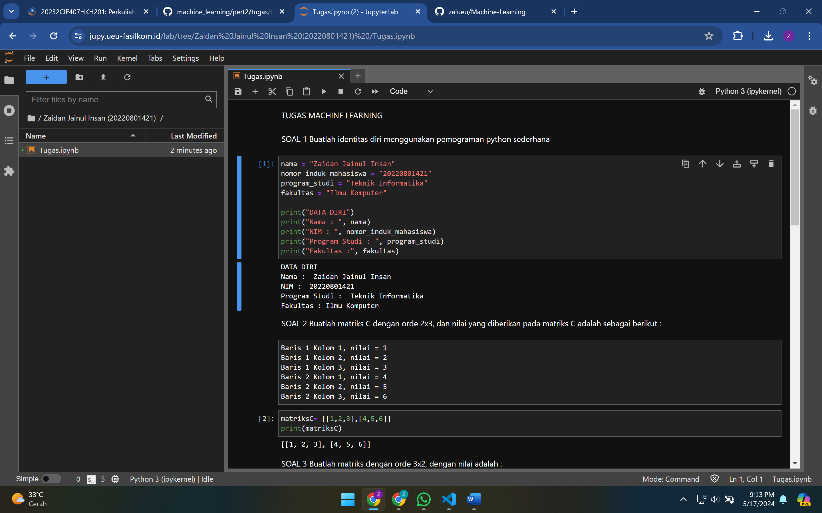

https://jupy.ueu-fasilkom.id/lab/tree/Zaidan%20Jainul%20Insan%20(20220801421)%20